User Platform Client usage

**Software Quality Verification Team**

ABSTRACT

This Guide briefly introduces the usage of TMP Client for software verification.

REVISION HISTORY

|  |  |  |
| --- | --- | --- |
| REVISION | RELEASE DATE | COMMENTS |
| V1.0 | 9/10/2016 | Initial draft |
|  |  |  |

CONTENTS

1 Preparation for TMP Client 4

1.1 What is TMPBQS 4

1.2 How to Install Software for TMP Client 4

1.3 Export TMP Client 4

2 Start TMP Client 5

3 Appendices 6

# 1 Preparation for TMP Client

## What is TMP

TMP (Test Management Platform) is Software unify regression platform.

## How to install Software for TMP Client

You should install the right versions of java, python and svn on your computer. If you have already install the software tools, you should check if their versions meet TMP client’s requirements. You can check their versions and/or install them in the following way:

Check java version by

**java –version**

If its version lower than 1.8, then install jre-8u92-windows-i586.exe file in \\lsh-smb01\sw\qa\qausr\jwang1\client_software.

Check python version by

**python –--version**

If its version is not 2.7.x, then install ActivePython-2.7.2.5-win32-x86.msi file in \\lsh-smb01\sw\qa\qausr\jwang1\client_software.

Check SVN version by

**svn –--version**

If its version is lower than 1.6.6, then  install Setup-Subversion-1.6.6.msi file in  \\lsh-smb01\sw\qa\qausr\jwang1\client_software.

## Export TMP Client

Under DOS Prompt, you can enter the following command under SVN folder:

svn export <http://linux12v/Platform/trunk/platforms/tmp/client/build/> TestRail_Client

then under SVN folder there is a folder **TestRail_Client** under which TMP client is installed.

* 1. **Set Up Configuration File**

You can enter **TestRail_Client/conf** folder, open **clientConf.conf** file, then check and update the following lines according to your computer environments:

* + Verify Diamond version and path,  remove unnecessary key=value pair;
  + If you have Modelsim, correct its path and version, or remove the relevant lines;
  + Do same check on other software;
  + Set initial value for maximum launched threads         max_procs = xx;
  + Set group name                                                                         group = xx;

It is important that you should set the group name to be the group name in Machine option in Suite file, unless you didn’t specify Machine name in Suite file.

# 2 Start TMP Client

Double click **client.exe**  under the folder TestRail_Client, or  run **java –jar client.jar** under this folder, to open TMP Client GUI interface as in Figure 1.

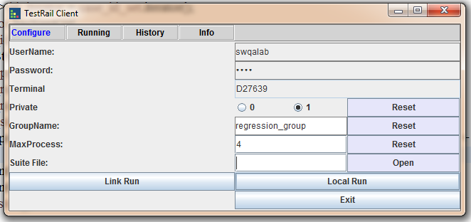

Figure 1 TMP Client

In this GUI, you can click **Open** for loading a suite file that describes the information on test case locations, their command lines etc.

Select **priority** 0 or 1: 0 for pubolic use, 1 for personal use.

Enter **Group Name** of this machine and **Max Process** the machine has. The relevant values in Configuration File are read and filled here as default values.

If select priority 0, then it means only those test runs created in the platform that have the priority 0, the same priority name and the same group name can use this machine; if select priority 1, then it means those test runs that have the priority 1, the same priority name and the same group name can use the machine first, then other test runs that have the same group name can use the machine in lower priority; if no priority is selected, then only those test runs without priority 0/1 in the same group can use the machine.

Click **Open** to open a dialog box, and then load a Suite file.

Click “**Local Run**” to run the suite on your computer.

Click “**Link Run**” to inform the server that the local resource is available for the server to use.

Click “**Running**” & “**Fresh**” to display the latest running cases.

Click “**History**” & “**Fresh**” to display the results of all finished cases. In this GUI, click on **Result** you can open a folder where the results for this case are located, as shown in Figure 2.

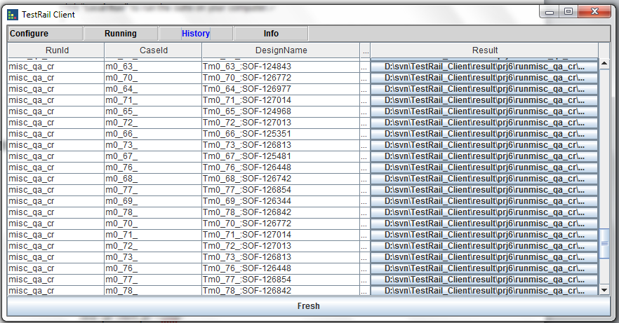

Figure 2 History

You can also see all the results under the folder **result** and file **check_flow.csv** under the folder **TestRail_Client**. Under the folder **result** the results of each case are stored in the folder tmX_YYY_, where **X** denotes the macro number defined in Suite file, and **YYY** denotes the case number specified in Order column in Suite file. The file **runtime_console.txt** in the fold **_scratch** contains the detailed information on the case in this run. The file **check_flow.csv** contains all the results for this run.

After start a new run, the History will be cleared, however, the results, including **check_flow.csv** and data in folder **result** will be not cleared. The new data will be added into the excel files, so you can delete the file **check_flow.csv** and the folders tmX_YYY_ in order not to mix the results of this run with the previous.

You can also run Client in CMD interface under DOS Prompt. You can refer to the detailed info by **java –jar client.jar --help**, where

**java –jar client.jar –-cmd**

inform the server the local resource is available for the server to use, and

**jave –jar client.jar –cmd –local –file suite_file**

to run the suite file on local machine.

[optional] ?????

You can find “check_flow.csv” in TestRail_reg01 folder for all case run info

You can find “skip_run.txt” in TestRail_reg01/log folder for skipped test cases and the reason.

# 3 Appendices